Directional Analysis of Wheelabrator Air Pollution in Baltimore
By: Hunter Baisden

ABSTRACT

The Wheelabrator Baltimore facility, now operating as WIN Waste Baltimore, is the largest stationary source of permitted air emissions within Baltimore city limits. It also sits less than a mile from Interstate 95, one of the busiest highway corridors on the East Coast. That location makes local pollution attribution difficult, because air measured nearby may reflect incinerator emissions, highway exhaust, regional transport, or some combination of all three.
This study asked whether daily PM2.5 measured at four federal air quality monitors in the Baltimore area was higher when those monitors were downwind of Wheelabrator than when they were downwind of I-95 alone. Six years of hourly wind data from the BWI airport weather station were combined with daily PM2.5 measurements and Wheelabrator's reported emissions. Each monitor-day was then classified as Wheelabrator only, I-95 only, both, or neither. Average PM2.5 was about forty-three percent higher on Wheelabrator-wind days than on highway-wind days, and the pattern held across three of the four monitors and three of the four seasons. However, the result cannot be treated as a clean source attribution. At several monitors, the directions to Wheelabrator and I-95 overlap, and roughly seven out of ten Wheelabrator-wind days occurred under southwesterly wind, the same pattern that can carry regional pollution into Baltimore. The study therefore identifies a meaningful directional signal, but not a precise estimate of Wheelabrator's direct contribution. The clearest next steps are fence-line monitoring in the closest neighborhoods, regional background correction, and a similar analysis using sulfur dioxide and nitrogen dioxide.

INTRODUCTION

There is a particular stretch of South Baltimore, running roughly from the Hanover Street bridge southward through Westport, Cherry Hill, Brooklyn, and Curtis Bay, where the cumulative environmental burden visible from the road is hard to ignore. A working coal pier sits on the water. A medical waste incinerator operates nearby. Several chemical and petroleum storage facilities line the south branch of the Patapsco. The Wheelabrator trash-burning incinerator, which is by the metric of permitted emissions the largest single air pollution source inside Baltimore city limits, sits at the foot of the same waterfront. And running parallel to all of this, less than a mile inland, Interstate 95 carries roughly two hundred thousand vehicles per day. The neighborhoods that bracket these sources are also among the lowest income census tracts in the city and have been the subject of ongoing environmental justice organizing for at least a decade.

Residents of those neighborhoods have argued for years that the air they breathe is worse than the air a few miles north. The broader scientific literature has been broadly supportive of that intuition. Fine particulate matter, the pollutant of focus in this study, is associated with elevated cardiopulmonary mortality even at long-term average concentrations well below the United States annual standard, and the World Health Organization's International Agency for Research on Cancer formally classified outdoor air pollution and particulate matter as carcinogenic to humans in 2013. What residents have not had, and what regulators have not really had either, is a clean local attribution number that says how much of the air pollution arriving at any given Baltimore neighborhood originates at any given local source.

The reason that number does not exist is that the attribution problem in Baltimore is unusually hard. The incinerator and the highway are physically next to each other. Their plumes mix downwind in proportions that depend on wind direction, atmospheric stability, and time of day. Baltimore also sits at the eastern edge of a large regional air shed that moves fine particulate pollution northeast from the Ohio Valley and the broader mid-Atlantic on prevailing southwesterly wind. The same wind direction that would carry incinerator plume into most of the populated parts of Baltimore is also the wind that imports regional pollution from hundreds of miles away. Any naive comparison that simply averages neighborhood-level pollution and points at the closest large emitter risks attributing regional transport to a local source.

This report describes a directional screening study designed to take a careful first pass at that attribution problem using only publicly available data. It is built around a single guiding question and reads as a continuous analysis. The discussion moves from the local source setting, through the data and directional method, into the main particulate-matter results, the monitor and seasonal stress tests, the confounders, and the limits of what can responsibly be concluded. Figures referenced in the text are listed in the appendix.

OBJECTIVE OF THE STUDY

The single research question for this study was as follows. Was ambient fine particulate matter higher when Baltimore-area air quality monitors were downwind of Wheelabrator than when those monitors were downwind of the I-95 corridor alone, and can any observed difference be cleanly separated from the contribution of regional pollution carried in on southwesterly wind?

The study had three concrete objectives in service of that question. The first was to classify, for every monitor day in the available record, whether the wind that day was carrying material from Wheelabrator toward the monitor, from I-95 toward the monitor, from both, or from neither. The second was to compare daily fine particulate concentrations across those four wind buckets at the level of the individual monitor, the season, and the metropolitan area. The third, and the one that did the most to shape the eventual conclusions, was to pressure-test the headline result against two specific confounders: the geometric overlap between the directions to Wheelabrator and to I-95 from each monitor's vantage, and the share of Wheelabrator-wind days that coincided with the southwesterly wind direction associated with regional pollution import. The objective was never to deliver a clean, source-specific attribution number. It was to surface the directional signal that exists in the data and to surface the confounders that would have to be addressed before that signal could be interpreted as a clean local effect.

ANALYSIS AND FINDINGS

The analysis begins with the basic geography of the problem. Two large air pollution sources sit very close to each other in South Baltimore: the Wheelabrator incinerator, which burns roughly two thousand tons per day of municipal solid waste and is the largest stationary air pollution source inside Baltimore city limits by permitted emissions, and Interstate 95, which carries hundreds of thousands of vehicles through the same waterfront corridor. Because the two sources are adjacent, most nearby neighborhoods are not simply exposed to one or the other in isolation. Depending on the wind, they may be downwind of the incinerator, the highway, both sources, or neither.

The central comparison is therefore not whether Baltimore air is polluted in an absolute sense. That question is already well documented and too broad for this study to answer in a source-specific way. The more useful question is whether fine particulate matter is higher when the wind is coming from the incinerator than when the wind is coming from the highway alone. Framing the problem this way treats I-95 as the baseline local transportation source and asks whether Wheelabrator appears to add a measurable increment above that baseline.

To make that comparison measurable, every monitor-day in the study was sorted into one of four directional categories. A day counted as a Wheelabrator-wind day at a given monitor when the wind spent more than half of the valid hourly observations blowing from the direction that would carry incinerator plume toward that monitor, using a forty-five-degree cone on either side of the straight-line bearing from Wheelabrator to the monitor. The same rule was applied to I-95, using the closest point on the highway to each monitor. If both directional tests were true, the day was classified as both. If neither was true, the day was classified as neither. This produced a direct, reproducible classification system rather than a modeled plume estimate.

The strength of that system is its simplicity. On any monitor-day, the wind either spent most of the day pointed from a source toward a monitor or it did not. The weakness is also built into geography: because Wheelabrator and I-95 sit so close together, their bearings overlap from several monitor locations. At those sites, a wind direction that appears to identify Wheelabrator may also be close to the highway direction. That geometric issue is not a side note; it becomes one of the central constraints on interpretation.

The neighborhood framing was broader than the monitor network. The study grouped nearby communities into three exposure categories: neighborhoods close to both Wheelabrator and I-95, neighborhoods along I-95 but far enough from Wheelabrator to serve as a highway comparison, and neighborhoods away from both sources that function as a quieter control group. The closest group includes Westport, Cherry Hill, Brooklyn, Curtis Bay, South Baltimore, and Federal Hill. The highway comparison group includes Elkridge, Savage, Laurel, Rossville, White Marsh, and Aberdeen. The control group includes neighborhoods outside the immediate influence of both sources.

The numerical evidence, however, comes from the federal air quality monitors with sufficient data rather than from every neighborhood named in the framing. Four monitors met that threshold: Oldtown in central Baltimore, Lake Montebello in northeast Baltimore, Padonia in Baltimore County, and Essex east of the city. The neighborhoods physically closest to Wheelabrator are not represented by a federal monitor in this dataset. That absence matters twice: it limits the precision of the analysis, and it points to a concrete environmental justice gap in the existing monitoring network.

Three public data streams support the analysis. Wheelabrator's reported emissions inventory establishes what the facility is permitted to release and what it reported releasing in recent inventory years. Six years of hourly wind observations from the BWI airport weather station provide the directional information needed to classify each monitor-day. Daily PM2.5 measurements from the four federal monitors provide the outcome being compared across wind categories. The method connects those sources by asking, for each hour and each monitor, whether the wind was coming from the direction of Wheelabrator, from the direction of I-95, from both, or from neither.

The emissions inventory confirms that Wheelabrator is large enough to warrant this kind of directional analysis. In its 2017 inventory year, the facility reported approximately 1,101 tons of nitrogen oxides, 308 tons of sulfur dioxide, 27 tons of fine particulate matter, and roughly 762,000 metric tons of carbon dioxide equivalent greenhouse gas emissions. Between 2014 and 2017, total reported emissions rose modestly rather than declining, with mercury and lead falling but hydrogen fluoride and nickel increasing. Those inventory values do not prove that any monitor reading came from Wheelabrator, but they establish that the facility is a substantial regulated source. Figure A1 summarizes the reported emissions.

Wind is the link between those emissions and the monitors. Across the six-year study window, the BWI station produced more than forty thousand valid hourly wind observations. Baltimore received wind from nearly every compass direction, with frequent wind from the west and northwest and a substantial secondary mode from the southwest. That day-to-day variability is what makes a directional comparison possible: the same monitor can be downwind of different source categories on different days. Figures A2 through A6 show the all-hours and seasonal wind roses.

The southwesterly wind pattern is especially important. Most of the study monitors lie north or northeast of Wheelabrator and the relevant I-95 corridor. A wind from the southwest can therefore carry local plume from South Baltimore toward those monitors. The same wind direction can also carry regional fine particulate pollution into Baltimore from the Ohio Valley and the broader mid-Atlantic. That overlap means that the wind most useful for identifying a possible Wheelabrator signal is also the wind most likely to import non-local pollution. Any interpretation of the results must carry that complication forward.

The main PM2.5 result is clear as a directional pattern. Across the four monitors, mean fine particulate concentration was approximately 9.0 micrograms per cubic meter on Wheelabrator-only days and approximately 6.3 micrograms per cubic meter on I-95-only days. That is a gap of roughly 43 percent relative to the highway-only mean. Days classified as both sat close to the Wheelabrator-only level, while days classified as neither were lower than either source-specific bucket. Figure A7 shows the four-bucket comparison.

That ordering is what one would expect if Wheelabrator were adding fine particulate pollution on top of an existing highway baseline: neither days are cleanest, highway-only days are intermediate, and days with Wheelabrator in the wind are highest. The aggregate sample size is large enough that this pattern is not just a small-number artifact. The result also remains directionally stable when the data are checked by monitor and by season. Still, the finding should be read as a directional signal, not as a clean source attribution. The data show that air was dirtier on Wheelabrator-wind days than on highway-wind days; they do not, by themselves, prove that Wheelabrator caused the full difference.

The monitor-level breakdown makes that caution necessary. Three of the four monitors lean in the same direction as the overall result. Oldtown showed the largest gap, with Wheelabrator-wind days approximately 60 percent higher than highway-wind days. Lake Montebello showed a 42 percent gap, and Padonia showed an 18 percent gap. Those positive results are large enough to take seriously despite the noise inherent in daily PM2.5 measurements. Figure A8 shows the monitor-by-monitor deltas.

Essex is the important exception. At Essex, highway-wind days were approximately 34 percent higher than Wheelabrator-wind days. That reversal is too large to dismiss as random noise. It is also especially informative because Essex has cleaner directional separation between Wheelabrator and I-95 than the other monitors. If the method captured a simple local incinerator effect, Essex would be expected to lean at least weakly in the same direction as the other sites. Instead, it flips. One plausible explanation is that Essex is influenced by a different local source mix on the eastern waterfront; another is that the apparent metro-wide Wheelabrator signal is partly inflated at monitors where the source bearings overlap.

Seasonal patterns add another layer. In spring, fall, and winter, Wheelabrator-wind days were roughly 60 percent higher than highway-wind days. In summer, the gap mostly disappeared as the four wind categories converged. This can be read in more than one way. Summer PM2.5 is often elevated across the eastern United States because secondary aerosol formation increases under warm, photochemically active conditions. A higher regional baseline can reduce the relative visibility of a fixed local source contribution. At the same time, summer is also a season when regional southwesterly transport can be especially important, meaning both the Wheelabrator and highway buckets may be contaminated by broader regional pollution. Figure A9 shows the seasonal comparison.

The monitor evidence supports the existence of a real pattern while also showing that the pattern is not uniform. Pollution roses, directional bar charts, daily time series, and seasonal views all tell a consistent story at Oldtown and Lake Montebello: higher readings tend to occur when winds come from the relevant southwest corridor. Padonia is weaker but still positive. Essex behaves differently. The daily time series do not suggest that the overall gap is driven only by a few unusually dirty days, and the seasonal comparisons do not isolate the pattern to a single season. The evidence therefore survives several simple stress tests, but it remains geographically uneven.

Two confounders define the outer limit of what this study can claim. The first is geometric. From three of the four monitor locations, the bearing to Wheelabrator and the bearing to the nearest point on I-95 are close enough that the directional buckets are not fully independent. A forty-five-degree cone around each source direction can overlap or come close to overlapping, especially for monitors far from both sources. That makes the Wheelabrator-only and I-95-only categories less clean than their names imply. The fourth monitor, Essex, has the cleanest separation and is also the one that reverses direction. Figure A10 summarizes the bearing overlap.

The second confounder is meteorological. Roughly seven out of ten Wheelabrator-wind days fell on southwesterly wind, while only about four out of ten highway-wind days did. Because southwesterly wind is also associated with regional pollution transport into Baltimore, the Wheelabrator bucket is more heavily exposed to regional background pollution than the highway bucket. Some unknown share of the 43 percent gap is therefore likely to be non-local. Without subtracting a regional background or using source-specific chemical fingerprints, the analysis cannot say how much of the gap belongs to Wheelabrator itself.

The defensible interpretation is that Baltimore-area PM2.5 was measurably higher on days when monitors were downwind of Wheelabrator than on days when they were downwind of I-95 alone, and that this pattern appears across three of four monitors and across three of four seasons. That is meaningful evidence of a directional signal. It is not sufficient evidence for a precise source-attribution number. The 43 percent difference should be treated as an upper bound on the possible local Wheelabrator effect, not as a measured estimate of the facility's direct contribution.

The limitations point directly to the next steps. The first limitation is regional transport: local plume and regional pollution can ride the same wind, so future work should subtract a regional background before assigning local impact. The second is reliance on a single airport weather station for the whole metro area; an urban wind sensor network would improve the directional classification. The third is daily averaging, which smooths over brief plume events that may matter for residents. The fourth is the absence of fence-line monitors in Westport, Cherry Hill, and Curtis Bay, the neighborhoods closest to Wheelabrator. The fifth is the focus on PM2.5 alone. Sulfur dioxide and nitrogen dioxide have shorter atmospheric lifetimes and may provide clearer local fingerprints for an incinerator-versus-highway comparison.

SUMMARY AND CONCLUSIONS

The strongest conclusion from this study is deliberately narrower than the headline number. Across four federal air quality monitors and six years of hourly wind data, fine particulate concentration was higher on Wheelabrator-wind days than on highway-only days. The average gap was approximately 43 percent, and the pattern held at three of four monitors and in three of four seasons. The ordering of concentrations across the wind buckets is consistent with the hypothesis that the incinerator contributes some pollution on top of an existing highway baseline.

The same evidence also prevents a clean attribution. Wheelabrator and I-95 are close enough together that the directional categories overlap from several monitor locations, and the Wheelabrator-wind bucket is disproportionately made up of southwesterly days that can import regional pollution into Baltimore. Essex, the monitor with the cleanest geometry, reverses the expected result. Those facts do not erase the directional signal, but they do mean the full 43 percent gap cannot responsibly be assigned to Wheelabrator alone.

The practical conclusion is that the signal is strong enough to justify better monitoring and cautious enough to avoid overclaiming. Fence-line monitors should be placed in the neighborhoods closest to the facility, especially Westport, Cherry Hill, and Curtis Bay. Future analysis should subtract regional background pollution, use more local wind observations, and repeat the directional method for sulfur dioxide and nitrogen dioxide. The most actionable finding is not only that PM2.5 rises on Wheelabrator-wind days, but that the people living closest to the facility are still not represented by the monitoring network that would be needed to evaluate that impact directly.
REFERENCES

Hand, J. L., Schichtel, B. A., Malm, W. C., & Frank, N. H. (2013). Spatial and temporal trends in PM2.5 organic and elemental carbon across the United States. Advances in Meteorology, 2013, Article 367674. https://doi.org/10.1155/2013/367674

Karner, A. A., Eisinger, D. S., & Niemeier, D. A. (2010). Near-roadway air quality: Synthesizing the findings from real-world data. Environmental Science & Technology, 44(14), 5334-5344. https://doi.org/10.1021/es100008x

Loomis, D., Grosse, Y., Lauby-Secretan, B., El Ghissassi, F., Bouvard, V., Benbrahim-Tallaa, L., Guha, N., Baan, R., Mattock, H., & Straif, K. (2013). The carcinogenicity of outdoor air pollution. The Lancet Oncology, 14(13), 1262-1263. https://doi.org/10.1016/S1470-2045(13)70487-X

Malm, W. C., Schichtel, B. A., Hand, J. L., & Collett, J. L. (2017). Concurrent temporal and spatial trends in sulfate and organic mass concentrations measured in the IMPROVE monitoring program. Journal of Geophysical Research: Atmospheres, 122(19), 10462-10476. https://doi.org/10.1002/2017JD026865

Pope, C. A., III, & Dockery, D. W. (2006). Health effects of fine particulate air pollution: Lines that connect. Journal of the Air & Waste Management Association, 56(6), 709-742. https://doi.org/10.1080/10473289.2006.10464485

Iowa Environmental Mesonet. (n.d.). ASOS-AWOS-METAR data download. Iowa State University Department of Agronomy. Retrieved May 6, 2026, from https://mesonet.agron.iastate.edu/request/download.phtml

U.S. Environmental Protection Agency. (n.d.). Greenhouse Gas Reporting Program: Facility Level Information on GreenHouse Gases Tool (FLIGHT). Facility ID 1004094. Retrieved May 6, 2026, from https://ghgdata.epa.gov

U.S. Environmental Protection Agency. (n.d.). Air Quality System (AQS) API documentation. Office of Air Quality Planning and Standards. Retrieved May 6, 2026, from https://aqs.epa.gov/aqsweb/documents/data_api.html

APPENDIX
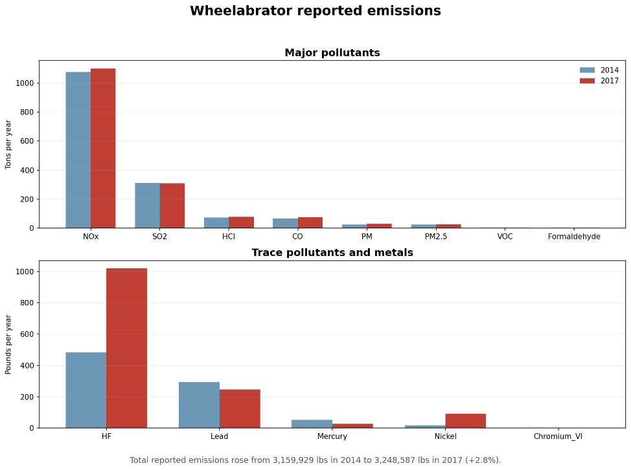
Figure A1. Wheelabrator reported emissions for major pollutants in 2014 and 2017.

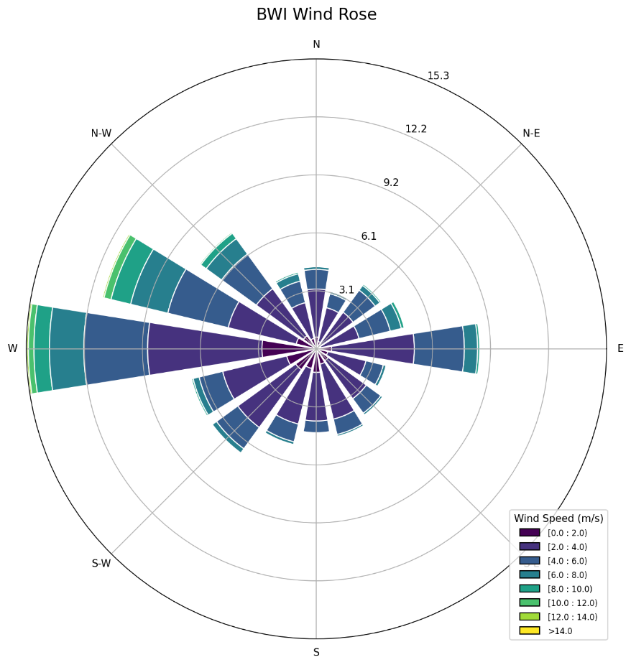
Figure A2. All-hours wind rose at BWI airport, six year window.

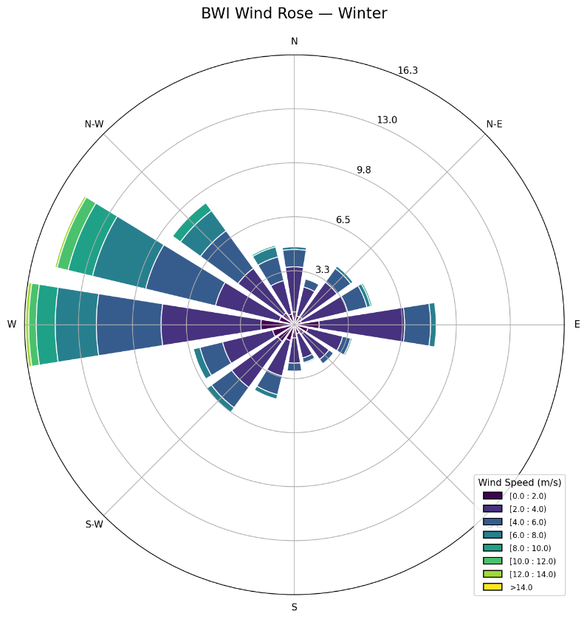
Figure A3. Winter wind rose at BWI airport.

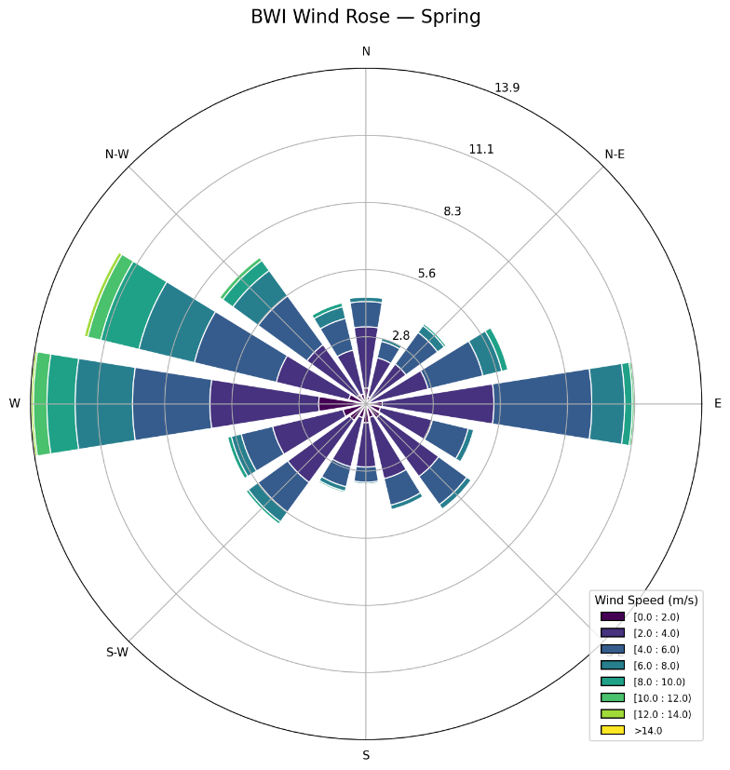
Figure A4. Spring wind rose at BWI airport.

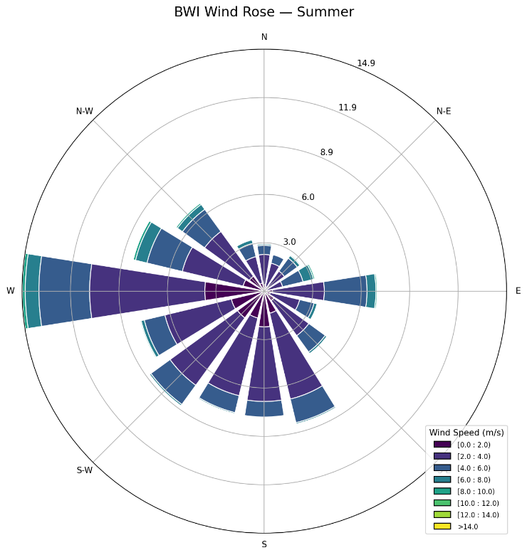
Figure A5. Summer wind rose at BWI airport.

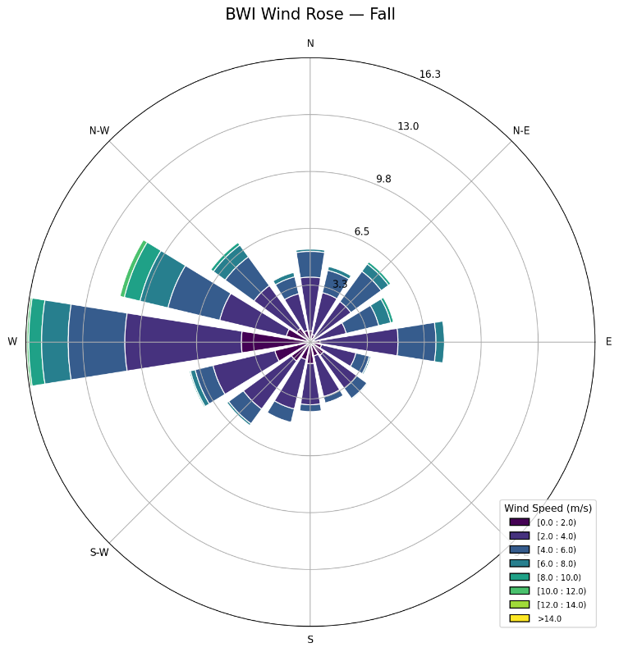
Figure A6. Fall wind rose at BWI airport.

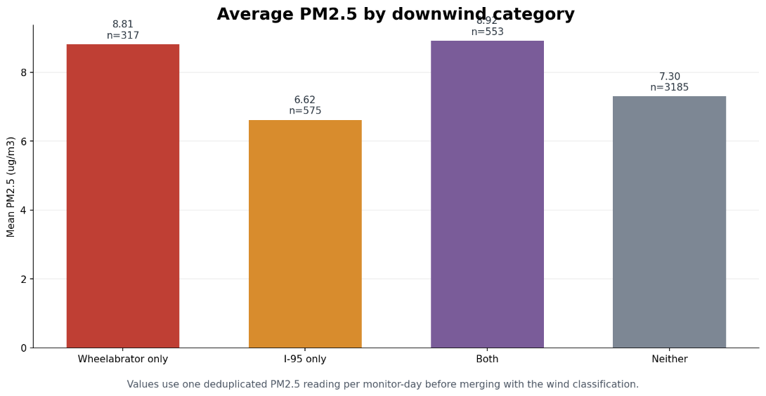
Figure A7. Mean fine particulate concentration by wind bucket across all four monitors and the full study window.

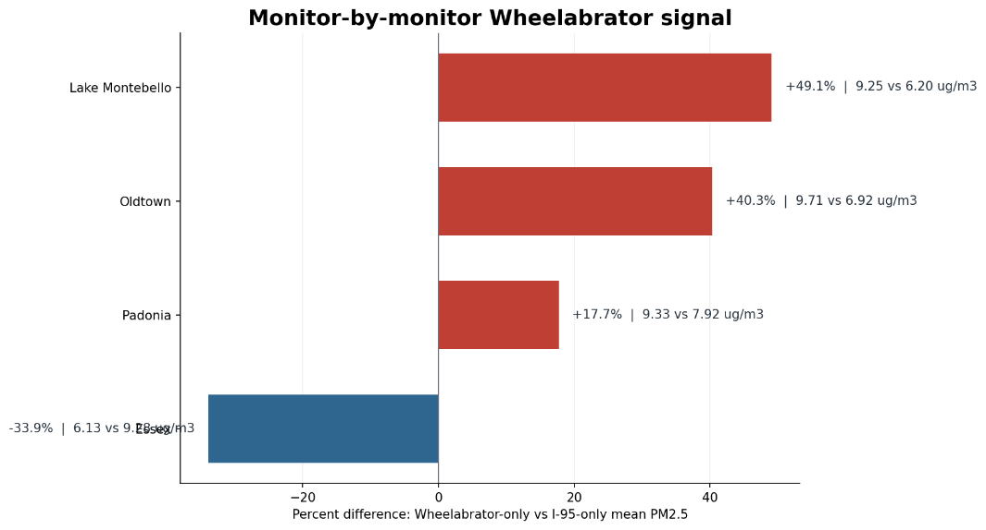
Figure A8. Per-monitor delta between Wheelabrator-only and I-95-only mean fine particulate concentration.

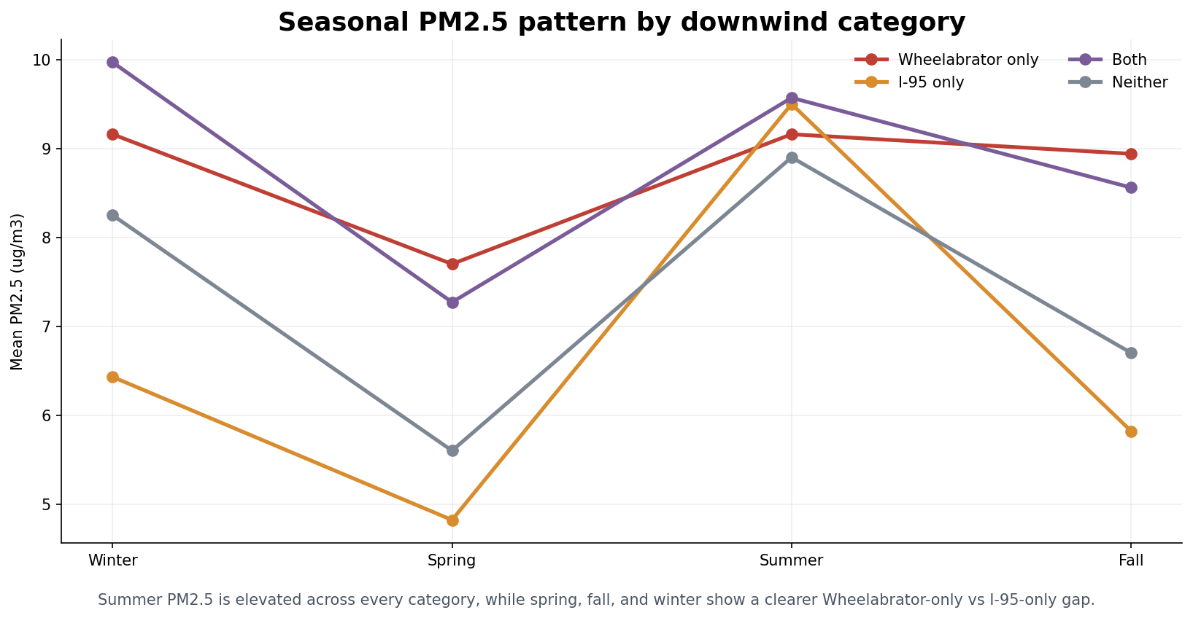
Figure A9. Seasonal mean fine particulate concentration by wind bucket.

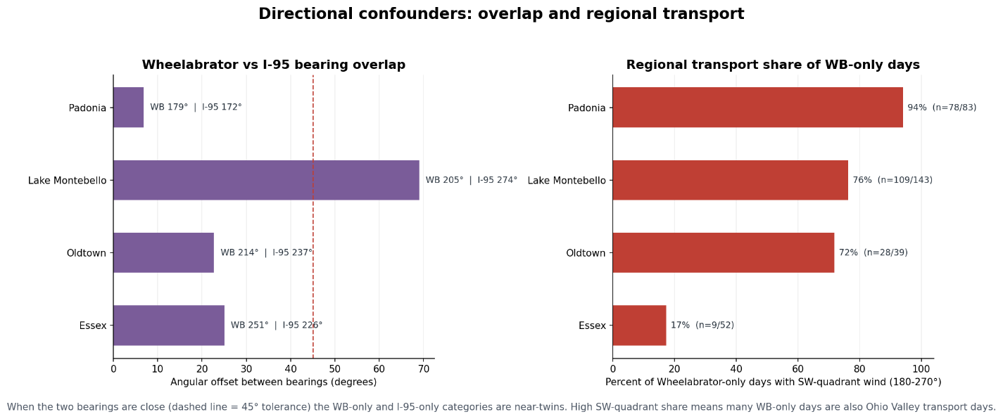
Figure A10. Confounder stress-test showing angular offset between the direction to Wheelabrator and the direction to the nearest point on I-95, alongside the share of Wheelabrator-only days on southwesterly wind, by monitor.

